**EXPERIMENT-1**

**Title:** To understand DDL and DML commands

**Objective:** To understand the concept of designing issue related to the database with creating, populating the tables. Also familiarize students with different ways of manipulation in database.

**1. Create the tables:**

**Table name:** CLIENT1

use lab_work;

CREATE TABLE CLIENT1 (

Colunmn_name varchar(10),

Name1 varchar(50),

ADDRESS1 varchar(30),

ADDRESS2 varchar(30),

CITY varchar(15),

PINCODE int,

STATE varchar(15),

BALDUE decimal(10,2)

);

**Table Name:** PRODUCT_MASTER

use lab_work;

CREATE TABLE PRODUCT_Master (

PRODUCTNO varchar(10),

DESCRIPTION1 varchar(50),

PROFITPERCENT decimal(4,2),

UNIT_MEASURE varchar(30),

QTYONHAND int,

REORDERL_VL int,

SELLPRICE decimaL (8,2),

COSTPRICE decimal(10,2)

);

**Table Name:** SALESMAN_MASTER

use lab_work;

CREATE TABLE SALESMAN_Master (

SALESMANNO varchar(10),

SALESMANName varchar(50),

ADDRESS1 varchar(30),

ADDRESS2 varchar(30),

CITY varchar(15),

PINCODE int,

STATE varchar(15)

);

**2. Insert the data into their respective tables:**

**CLIENT1**

use lab_work;

INSERT INTO CLIENT1

VALUES('C00001', 'Ivan bayross','ANDHERI ','EAST', 'Mumbai', 400054, 'Maharashtra', 15000),

('C00002', 'Mamta muzumdar', 'Shanthi Colony Main Road','AI Block','Madras', 780001, 'Tamil nadu', 0),

('C00003', 'Chhaya bankar','ANDHERI','WEST', 'Mumbai', 400057 ,'Maharashtra' ,5000),

('C00004', 'Ashwini joshi', 'Sarvepalli Radhakrishnan Rd','Soladevanahalli', 'Bangalore', 560001, 'Karnataka', 0),

('C00005', 'Hansel colaco', 'Goregaon', 'WEST', 'Mumbai', 400060, 'Maharashtra', 2000),

('C00006', 'Deepak sharma','Sturrock Rd','Attavar', 'Mangalore', 560050 ,'Karnataka', 0);

**PRODUCT_MASTER**

use lab_work;

INSERT INTO PRODUCT_Master

VALUES('P00001', 'T-Shirt', 5 ,'Piece', 200,50, 350, 250),

('P0345', 'Shirts', 6, 'Piece', 150 ,50 ,500, 350),

('P06734' ,'Cotton jeans' ,5 ,'Piece' ,100 ,20 ,600,450),

('P07865' ,'Jeans', 5 ,'Piece', 100, 20, 750, 500),

('P07868' ,'Trousers' ,2 ,'Piece' ,150 ,50 ,850 ,550),

('P07885', 'Pull Overs', 2.5, 'Piece', 80, 30, 700, 450),

('P07965', 'Denim jeans' ,4 ,'Piece' ,100 ,40 ,350 ,250),

('P07975', 'Lycra tops', 5, 'Piece', 70, 30 ,300, 175),

('P08865' ,'Skirts ',5 ,'Piece' ,75 ,30 ,450 ,300);

**SALESMAN_MASTER**

use lab_work;

INSERT INTO SALESMAN_Master

VALUES( 'S00001' ,'Aman' ,'A/14','Worli','Mumbai',400002,'Maharashtra'),

('S00002', 'Omkar','65','Nariman', 'Mumbai', 400001, 'Maharashtra'),

('S00003' ,'Raj' ,'P-7', 'Bandra','Mumbai',400032 ,'Maharashtra'),

('S00004' ,'Ashish' ,'A/5','Juhu','Mumbai',400044 ,'Maharashtra');

**Output**

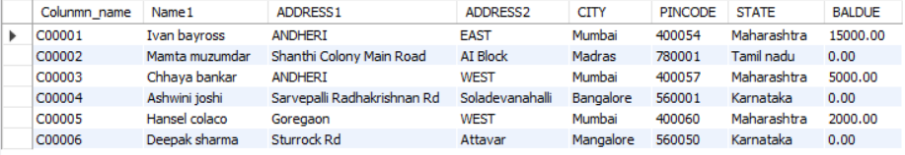

**CLIENT1**

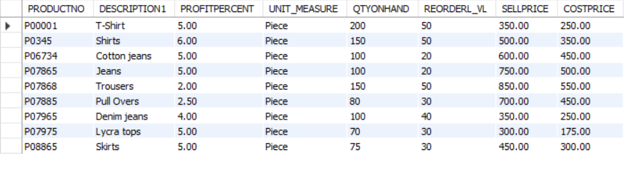

**PRODUCT_Master**

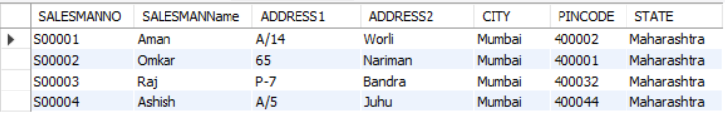

**SALESMAN_Master**

**3. Exercise on retrieving records from a table**

a. Find out the names of all the clients.

use lab_work;

select Name1 from CLIENT1;

**Output:**

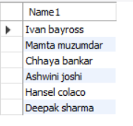

b. Retrieve the entire contents of the Client_Master table

use lab_work;

select * from CLIENT1 ;

**Output:**

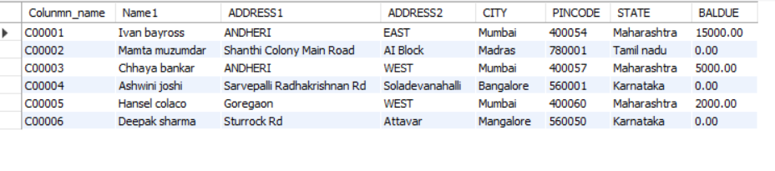

c. Retrieve the list of names, city and the state of all the clients.

use lab_work;

select Name1,CITY,STATE from CLIENT1;

**Output:**

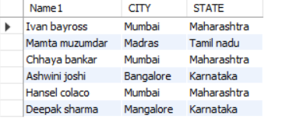

d. List the various products available from the Product_Master table.

use lab_work;

select DESCRIPTION1 from PRODUCT_Master;

**Output:**

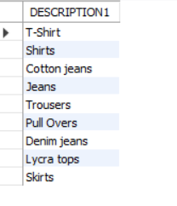

e. List all the clients who are located in Mumbai.

use lab_work;

select * from CLIENT1 where CITY = 'Mumbai';

**Output:**

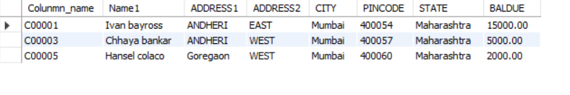

**4. Exercise on updating records in a table**

a. Change the city of ClientNo ‘C00005’ to ‘Bangalore’

use lab_work;

update CLIENT1 set CITY = 'Banglore' where Colunmn_name = 'C00005';

**Output:**

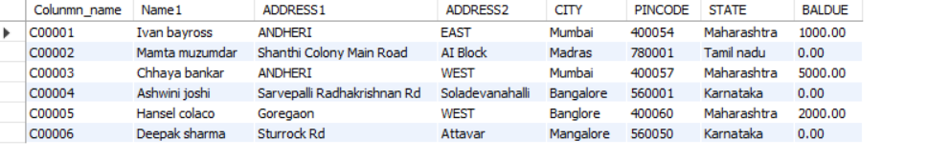

b. Change the BalDue of ClientNo ‘C00001’ to Rs.1000.

use lab_work;

update CLIENT1 set BALDUE = 1000 where Colunmn_name = 'C00001';

**Output:**

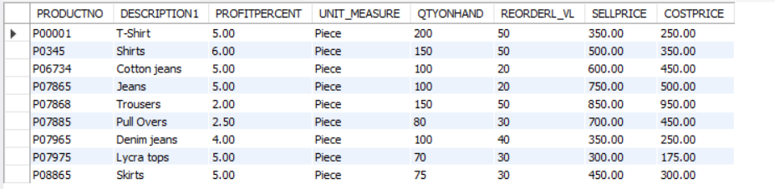

c. Change the city of the salesman to Pune.

use lab_work;

update SALESMAN_Master set CITY = 'Pune' ;

**Output:**

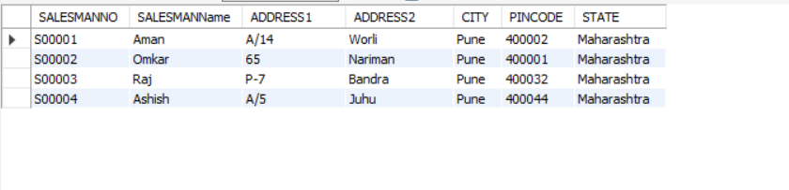

**5. Exercise on deleting records in a table**

a. Delete all products from Product_Master where the quantity on hand is equal to 100

use lab_work;

DELETE FROM PRODUCT_Master where QTYONHAND =100;

**Output:**

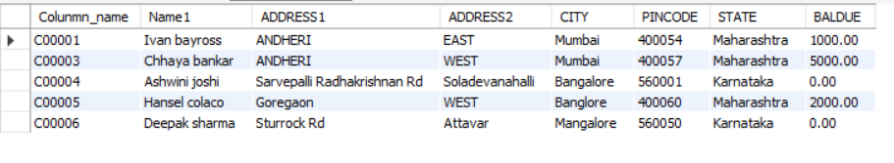

b. Delete from Client1 where the column state holds the value ‘Tamil Nadu’

use lab_work;

DELETE FROM CLIENT1 where STATE ='Tamil nadu';

**Output:**



**6. Exercise on altering the table structure**

a. Add a column called ‘Telephone’ of data type integer to the Client_Master table

use lab_work;

alter Table CLIENT1 Add telephone int(10);

**Output:**

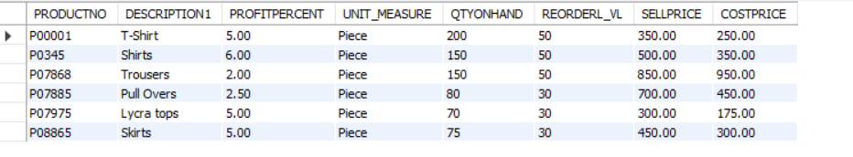

b. Change the size off SellPrice column in Product _Master to 10, 2.

use lab_work;

alter Table PRODUCT_Master Modify SELLPRICE decimaL (10,2);

**7. Exercise on deleting the table structure along with the data**

a. Destroy the table Client1 along with its data.

use lab_work;

DROP TABLE CLIENT1;

**8. Exercise on renaming the table**

a. Change the name of the Salesman_Master to sman_mast

use lab_work;

Alter Table SALESMAN_Master Rename to sman_mast;